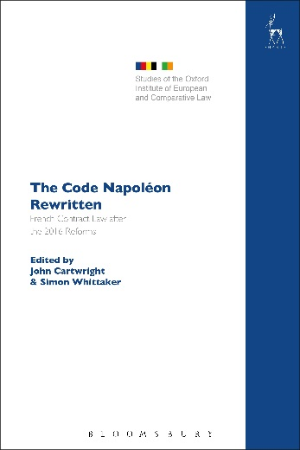
The Code Napoléon Rewritten
French Contract Law after the 2016 Reforms
Edited by John Cartwright and Simon Whittaker

The provisions of the French Civil Code governing the law of obligations have remained largely unchanged since 1804 and have served as the model for civil codes across the world. In 2016, the French Government effected major reforms of the provisions on the law of contract, the general regime of obligations and proof of obligations. This work explores in detail the most interesting new provisions on French contract law in a series of essays by French lawyers and comparative lawyers working on French law and other civil law systems. It will make these fundamental reforms accessible to an English-speaking audience.

John Cartwright is Professor of the Law of Contract at the University of Oxford and Director of the Oxford Law Faculty's Institute of European and Comparative Law.
Simon Whittaker is Professor of European Comparative Law at the University of Oxford.

October 2017 | 9781509911608 | 536pp | Hardback | RSP: £90
Discount Price: £72

Click here to order online – use the code ODG at the checkout to get 20% off!

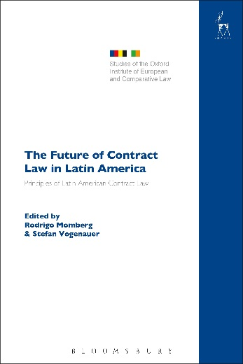
The Future of Contract Law in Latin America
The Principles of Latin American Contract Law
Edited by Rodrigo Momberg and Stefan Vogenauer

This book presents, analyses and evaluates the Principles of Latin American Contract Law (PLACL), a recent set of provisions aiming at the harmonisation of contract law at a regional level. As such, the PLACL are the most recent exponent of the many proposals for transnational sets of ‘principles of contract law’ that were drafted or published over the past 20 years, either at the global or the regional level. These include the UNIDROIT Principles of International Commercial Contracts, the Principles of European Contract Law, the (European) Draft Common Frame of Reference and the Principles of Asian Contract Law.

The PLACL are the product of a working group comprising legal academics from Argentina, Brazil, Colombia, Chile, Paraguay, Uruguay and Venezuela. The 111 articles of the instrument deal with problems of general contract law, such as formation, interpretation and performance of contracts, as well as remedies for breach.
The book aims to introduce the PLACL to an international audience by putting them in their historical and comparative context, including other transnational harmonisation measures and initiatives. The contributions are authored by drafters of the PLACL and contract law experts from Europe and Latin America.

Rodrigo Momberg is Professor of Private Law at the Catholic University of Valparaiso.
Stefan Vogenauer is Director of the Max Planck Institute for European Legal History, Frankfurt.

September 2017 9781509914272 352pp Hardback RSP: £85
Discount Price: £68

Click here to order online – use the code ODG at the checkout to get 20% discount!

